ISM6208 Data Warehousing Final Project  
James Long

USF Summer 2021

Contents

Executive Summary 2

Problem Statement 2

Data Collection and Preparation 2

Database Design 3

Operational Model 16

Reporting 18

Modeling 23

Storytelling 31

Conclusions 35

# Executive Summary

This paper presents the processes for and results of building a very basic predictive model for major U.S. stock indexes based on core economic data. The model is dimensional and based on a relational star schema. I am particularly interested in the influence the Federal Reserve has on the markets, so my model uses predictors aligned with the Fed's mandate (employment and inflation) along with the Federal Funds rate.

This basic model could evolve to include something like a “Fed Sentiment” fact table. The purpose would be to capture and quantify how hawkish or dovish Fed comments are whenever a member of the Fed makes public comments. Natural Language Processing (NLP) or other Artificial Intelligence (AI) techniques could be used to assign a numeric value to the sentiment indicator for each Fed comment. Due to lack of time and data, I modeled this concept but did not implement it.

This project is the culmination of effort performed over the span of a six-week semester. A large set of financial data was already available within the course DBMS, so I relied on it as my primary data source. This enabled me to focus more on modeling, visualizing, and mining. The project incorporates some of the work assigned earlier in the semester and builds upon it to meet the project requirements. Though given the option to work in a group, I worked alone to maximize my learning outcomes.

# Problem Statement

Accurately predicting stock moves is notoriously difficult yet extremely alluring due to the potential rewards. Everyone that has any investment in stock (401k, IRA, pension, retail broker, etc.) has a motive to solve this problem. Unfortunately, countless variables influence stock market movements, and the influence of each variable changes daily or even hourly. This creates both opportunity and risk every trading day in every stock market around the globe. For many families, solving this puzzle with even modest reliability could mean the difference between private transportation or public transit, buying a home or renting an apartment, private or public school. Otherwise, long term investing is the only safe option. While that helps with retirement, it does not pay the bills due today. Data mining and visualization could uncover patterns that help to solve this challenge.

# Data Collection and Preparation

Most of the data I used were already in the FIN schema. I replicated these data to my personal schema and modified them as needed by dropping columns, adding columns, renaming columns, populating columns, etc. In the case of the Employment_Facts table, I also dropped some rows of older data that preceded the earliest month in the Cal_Month_Dim_MV materialized view.

No data were available in the DMBS for inflation rates. So, I searched the FRED site for relevant series. Many series were indexed to a particular year, so they would not correlate with other data that fluctuated monthly. Fortunately, I found a mean Consumer Price Index (CPI) series produced by the Federal Reserve Bank of Dallas (FRBD) on the monthly basis. Prior to loading that into my schema, I dropped the rows of newer data that succeeded the latest month in the Cal_Month_Dim_MV materialized view (July 2018).

No data were available in the DMBS for Fed fund rates after March 2012. So, I downloaded the same series from the FRED site, dropped the rows that were already in the DBMS, and then inserted new rows into the Fed_Reserve_Facts table to fill in missing data from April 2012 to July 2018.

No data were available in the DMBS for BLS unemployment rates after March 2015. So, I downloaded the same series from the FRED site, dropped the rows that were already in the DBMS, and then inserted new rows into the Employments_Facts table to fill in missing data from April 2015 to July 2018.

# Database Design

The following ERD depicts the dimensional schema I created for this project.

**Monthly Grain**

I am not interested in quarterly aggregates because I want to know how to trade index ETFs leading up to Fed meetings, public Fed comments, events featuring Fed speakers, etc. Too many such events occur in a quarter for that time span to be useful. So, I only created a monthly aggregate for the date table. Most of the fact tables contain data produced on a monthly basis, so this grain works well for aggregation.

**52 Week Data**

The “52 week” facts in the STK_Index_Mon_Aggs materialized view record the highest and lowest values during each aggregate period (not the average). The “52 week” dates in the STK_Index_Dim table are based on the trailing twelve months.

**World Events**

The World_Events_Dim table attempts to capture some of the market's psychological factors. This could help explain temporary deviations from the normal correlation of indicator facts to index price movements. For example, Pre_Recession would indicate the month prior to the formal start of a recession, whereas Post_Recession would indicate the month after the formal end of a recession. Some of the other attributes probably should be modeled granularly like recession. For now, they serve as placeholders to indicate the types of events that might be relevant.

**Fed Sentiment**

The grain of the Fed_Sentiment_Facts table is daily, so we expect the fact table to be sparsely populated. The date alone is insufficient to uniquely identify each row because multiple events can occur on a single day. So, a system-generated identity field is included in the primary key. An event type is included to inform us of the nature of the event at which comments were made, but this is modeled as a degenerate dimension on the assumption we do not need to know anything about specific events. An event weight is assigned to each event type to indicate the relevant importance. This enables us to calculate a weighted average of the sentiment level in the monthly aggregate view. We need this because some comments (e.g., FOMC meeting minutes or the dot plot) have more impact on market psychology than other comments (e.g., a Fed President speaking at a business conference). This sentiment concept was modeled but not instantiated since I had no data.

**SQL Code**

I issued the following SQL commands to instantiate the tables within my personal schema (DW787).

CREATE TABLE

STK_DATE_DIM

AS

SELECT

*

FROM

FIN.STK_DATE_DIMS SDD

INNER JOIN

(SELECT

JULIAN_DAY_KEY AS DAY_KEY,

TO_NUMBER(TO_CHAR(CAL_DATE, 'YYYYMM'),'999999') AS CAL_MONTH_KEY

FROM

FIN.STK_DATE_DIMS) CMK

ON SDD.JULIAN_DAY_KEY=CMK.DAY_KEY;

ALTER TABLE

STK_DATE_DIM

DROP COLUMN DAY_KEY;

ALTER TABLE

STK_DATE_DIM

ADD CONSTRAINT

STK_DATE_DIM_PK

PRIMARY KEY

(JULIAN_DAY_KEY);

ALTER TABLE

STK_DATE_DIM

ADD CONSTRAINT

STK_DATE_MONTH_FK

FOREIGN KEY

(CAL_MONTH_KEY)

REFERENCES

CAL_MONTH_DIM_MV(CAL_MONTH_KEY);

CREATE TABLE

STK_INDEX_DIM

AS

SELECT

*

FROM

FIN.STK_INDEX_DIMS;

ALTER TABLE

STK_INDEX_DIM

ADD CONSTRAINT

STK_INDEX_DIM_PK

PRIMARY KEY

(INDEX_KEY);

ALTER TABLE

STK_INDEX_DIM

ADD HIGH_52_WEEK_DATE DATE;

ALTER TABLE

STK_INDEX_DIM

ADD LOW_52_WEEK_DATE DATE;

CREATE TABLE

STK_INDEX_FACTS

AS

SELECT

*

FROM

FIN.STK_INDEX_FACTS IF

INNER JOIN

(SELECT

TRADE_DATE AS TD,

INDEX_KEY AS IK,

ROUND(MAX(HIGH) OVER (PARTITION BY INDEX_KEY ORDER BY TRADE_DATE ASC RANGE INTERVAL '365' DAY(3) PRECEDING),2) AS HIGH_52_WEEK,

ROUND(MIN(LOW) OVER (PARTITION BY INDEX_KEY ORDER BY TRADE_DATE ASC RANGE INTERVAL '365' DAY(3) PRECEDING),2) AS LOW_52_WEEK

FROM

FIN.STK_INDEX_FACTS

ORDER BY TRADE_DATE, INDEX_KEY) HL

ON IF.TRADE_DATE=HL.TD AND IF.INDEX_KEY=HL.IK;

ALTER TABLE

STK_INDEX_FACTS

DROP COLUMN TD;

ALTER TABLE

STK_INDEX_FACTS

DROP COLUMN IK;

ALTER TABLE

STK_INDEX_FACTS

ADD CONSTRAINT

STK_INDEX_FACTS_PK

PRIMARY KEY

(INDEX_KEY, JULIAN_DAY_KEY);

ALTER TABLE

STK_INDEX_FACTS

ADD CONSTRAINT

STK_INDEX_INDEX_FK

FOREIGN KEY

(INDEX_KEY)

REFERENCES

STK_INDEX_DIM(INDEX_KEY);

ALTER TABLE

STK_INDEX_FACTS

ADD CONSTRAINT

STK_INDEX_JULIAN_FK

FOREIGN KEY

(JULIAN_DAY_KEY)

REFERENCES

STK_DATE_DIM(JULIAN_DAY_KEY);

CREATE MATERIALIZED VIEW

CAL_MONTH_DIM_MV

BUILD IMMEDIATE

REFRESH FORCE

ON DEMAND

AS

SELECT DISTINCT

CAL_MONTH_KEY,

MONTH_NAME,

MONTH_ABBREV,

MONTH_NBR,

YEAR_NAME,

YEAR_NBR

FROM

STK_DATE_DIM;

ALTER MATERIALIZED VIEW

CAL_MONTH_DIM_MV

ADD CONSTRAINT

CAL_MONTH_DIM_MV_PK PRIMARY KEY("CAL_MONTH_KEY");

ALTER MATERIALIZED VIEW

CAL_MONTH_DIM_MV

ADD CONSTRAINT

CAL_MONTH_DIM_MV_PK_NOT_NULL check("CAL_MONTH_KEY" IS NOT NULL) ENABLE;

EXEC DBMS_STATS.GATHER_TABLE_STATS('DW787', 'CAL_MONTH_DIM_MV');

CREATE MATERIALIZED VIEW

STK_INDEX_MON_AGGS

BUILD IMMEDIATE

REFRESH FORCE

ON DEMAND

AS

SELECT

CAL_MONTH_KEY,

INDEX_KEY,

ROUND(AVG(OPEN),2) AS AVG_OPEN,

ROUND(AVG(HIGH),2) AS AVG_HIGH,

ROUND(AVG(LOW),2) AS AVG_LOW,

ROUND(AVG(CLOSE),2) AS AVG_CLOSE,

ROUND(AVG(ADJ_CLOSE),2) AS AVG_ADJ_CLOSE,

ROUND(AVG(VOLUME),0) AS AVG_VOLUME,

MAX(HIGH_52_WEEK) AS HIGH_52_WEEK,

MIN(LOW_52_WEEK) AS LOW_52_WEEK

FROM

STK_DATE_DIM DD

INNER JOIN STK_INDEX_FACTS IF

ON DD.JULIAN_DAY_KEY=IF.JULIAN_DAY_KEY

GROUP BY CAL_MONTH_KEY, INDEX_KEY

ORDER BY CAL_MONTH_KEY, INDEX_KEY;

ALTER MATERIALIZED VIEW

STK_INDEX_MON_AGGS

ADD CONSTRAINT

SYS_C12345678 check("CAL_MONTH_KEY" IS NOT NULL) ENABLE;

ALTER MATERIALIZED VIEW

STK_INDEX_MON_AGGS

ADD CONSTRAINT

STK_INDEX_MON_AGGS_PK PRIMARY KEY("CAL_MONTH_KEY","INDEX_KEY");

ALTER MATERIALIZED VIEW

STK_INDEX_MON_AGGS

ADD CONSTRAINT

STK_INDEX_AGGS_CAL_MON_FK

FOREIGN KEY

(CAL_MONTH_KEY)

REFERENCES

CAL_MONTH_DIM_MV(CAL_MONTH_KEY);

ALTER MATERIALIZED VIEW

STK_INDEX_MON_AGGS

ADD CONSTRAINT

STK_INDEX_AGGS_INDEX_FK

FOREIGN KEY

(INDEX_KEY)

REFERENCES

STK_INDEX_DIM(INDEX_KEY);

EXEC DBMS_STATS.GATHER_TABLE_STATS('DW787', 'STK_INDEX_MON_AGGS');

UPDATE

STK_INDEX_DIM

SET

HIGH_52_WEEK_DATE=

(SELECT

MIN(TRADE_DATE)

FROM

STK_INDEX_FACTS

WHERE

INDEX_KEY=101

AND TRADE_DATE >='11-JUL-17'

AND HIGH_52_WEEK=(SELECT

MAX(HIGH_52_WEEK)

FROM

STK_INDEX_FACTS

WHERE

INDEX_KEY=101

AND TRADE_DATE >='11-JUL-17'))

WHERE

INDEX_KEY=101;

UPDATE

STK_INDEX_DIM

SET

HIGH_52_WEEK_DATE=

(SELECT

MIN(TRADE_DATE)

FROM

STK_INDEX_FACTS

WHERE

INDEX_KEY=102

AND TRADE_DATE >='11-JUL-17'

AND HIGH_52_WEEK=(SELECT

MAX(HIGH_52_WEEK)

FROM

STK_INDEX_FACTS

WHERE

INDEX_KEY=102

AND TRADE_DATE >='11-JUL-17'))

WHERE

INDEX_KEY=102;

UPDATE

STK_INDEX_DIM

SET

HIGH_52_WEEK_DATE=

(SELECT

MIN(TRADE_DATE)

FROM

STK_INDEX_FACTS

WHERE

INDEX_KEY=103

AND TRADE_DATE >='11-JUL-17'

AND HIGH_52_WEEK=(SELECT

MAX(HIGH_52_WEEK)

FROM

STK_INDEX_FACTS

WHERE

INDEX_KEY=103

AND TRADE_DATE >='11-JUL-17'))

WHERE

INDEX_KEY=103;

UPDATE

STK_INDEX_DIM

SET

LOW_52_WEEK_DATE=

(SELECT

MIN(TRADE_DATE)

FROM

STK_INDEX_FACTS

WHERE

INDEX_KEY=101

AND TRADE_DATE >='11-JUL-17'

AND LOW_52_WEEK=(SELECT

MIN(LOW_52_WEEK)

FROM

STK_INDEX_FACTS

WHERE

INDEX_KEY=101

AND TRADE_DATE >='11-JUL-17'))

WHERE

INDEX_KEY=101;

UPDATE

STK_INDEX_DIM

SET

LOW_52_WEEK_DATE=

(SELECT

MIN(TRADE_DATE)

FROM

STK_INDEX_FACTS

WHERE

INDEX_KEY=102

AND TRADE_DATE >='11-JUL-17'

AND LOW_52_WEEK=(SELECT

MIN(LOW_52_WEEK)

FROM

STK_INDEX_FACTS

WHERE

INDEX_KEY=102

AND TRADE_DATE >='11-JUL-17'))

WHERE

INDEX_KEY=102;

UPDATE

STK_INDEX_DIM

SET

LOW_52_WEEK_DATE=

(SELECT

MIN(TRADE_DATE)

FROM

STK_INDEX_FACTS

WHERE

INDEX_KEY=103

AND TRADE_DATE >='11-JUL-17'

AND LOW_52_WEEK=(SELECT

MIN(LOW_52_WEEK)

FROM

STK_INDEX_FACTS

WHERE

INDEX_KEY=103

AND TRADE_DATE >='11-JUL-17'))

WHERE

INDEX_KEY=103;

CREATE TABLE WORLD_EVENTS_DIM (

WORLD_EVENTS_KEY NUMBER(4,0) GENERATED BY DEFAULT AS IDENTITY,

PRE_RECESSION VARCHAR2(5 BYTE),

IN_RECESSION VARCHAR2(5 BYTE),

POST_RECESSION VARCHAR2(5 BYTE),

WAR_DECLARED VARCHAR2(5 BYTE),

WAR_ENDED VARCHAR2(5 BYTE),

FEDERAL_ELECTION_MONTH VARCHAR2(5 BYTE),

FEDERAL_ELECTION_YEAR VARCHAR2(5 BYTE),

GEOPOLITICAL_EVENT VARCHAR2(5 BYTE),

ENERGY_EVENT VARCHAR2(5 BYTE),

IN_PANDEMIC VARCHAR2(5 BYTE)

);

ALTER TABLE

WORLD_EVENTS_DIM

ADD CONSTRAINT

WORLD_EVENTS_DIM_PK PRIMARY KEY ("WORLD_EVENTS_KEY");

INSERT INTO WORLD_EVENTS_DIM (

PRE_RECESSION,

IN_RECESSION,

POST_RECESSION,

WAR_DECLARED,

WAR_ENDED,

FEDERAL_ELECTION_MONTH,

FEDERAL_ELECTION_YEAR,

GEOPOLITICAL_EVENT,

ENERGY_EVENT,

IN_PANDEMIC)

VALUES

(NULL,NULL,NULL,NULL,NULL,NULL,NULL,NULL,NULL,NULL);

CREATE TABLE

EMPLOYMENT_FACTS

AS

SELECT

CAL_MONTH_KEY,

UNRATE_PERCENT AS BLS_UNEMP_RATE,

CAST(NULL AS NUMBER) AS BLS_PARTICIPATION_RATE,

CAST(NULL AS NUMBER) AS BLS_NONFARM_PAYROLL_EMP,

CAST(NULL AS NUMBER) AS ADP_NATIONAL_EMP,

1 AS WORLD_EVENTS_KEY

FROM

FIN.FRED_UNRATE;

ALTER TABLE

EMPLOYMENT_FACTS

ADD CONSTRAINT

EMPLOYMENT_FACTS_PK PRIMARY KEY ("CAL_MONTH_KEY");

DELETE

FROM

EMPLOYMENT_FACTS

WHERE

CAL_MONTH_KEY IN (194801, 194802, 194803, 194804, 194805, 194806, 194807, 194808, 194809, 194810, 194811, 194812, 194901, 194902, 194903, 194904, 194905, 194906, 194907, 194908, 194909, 194910, 194911, 194912);

ALTER TABLE

EMPLOYMENT_FACTS

ADD CONSTRAINT

EMPLOYMENT_FACTS_MONTH_FK

FOREIGN KEY

("CAL_MONTH_KEY")

REFERENCES

"CAL_MONTH_DIM_MV"("CAL_MONTH_KEY");

ALTER TABLE

EMPLOYMENT_FACTS

ADD CONSTRAINT

EMPLOYMENT_FACTS_WORLD_FK

FOREIGN KEY

("WORLD_EVENTS_KEY")

REFERENCES

"WORLD_EVENTS_DIM"("WORLD_EVENTS_KEY");

CREATE TABLE

FED_RESERVE_FACTS

AS

SELECT

CAL_MONTH_KEY,

FF_RATE AS FED_FUND_RATE,

CAST(NULL AS NUMBER) AS QE_PURCHASE_AMT,

1 AS WORLD_EVENTS_KEY

FROM

FIN.FRED_FEDFUNDS;

ALTER TABLE

FED_RESERVE_FACTS

ADD CONSTRAINT

FED_RESERVE_FACTS_PK PRIMARY KEY ("CAL_MONTH_KEY");

ALTER TABLE

FED_RESERVE_FACTS

ADD CONSTRAINT

FRF_PK_NOT_NULL CHECK ("CAL_MONTH_KEY" IS NOT NULL) ENABLE;

ALTER TABLE

FED_RESERVE_FACTS

ADD CONSTRAINT

FED_RESERVE_MONTH_FK

FOREIGN KEY

("CAL_MONTH_KEY")

REFERENCES

"CAL_MONTH_DIM_MV" ("CAL_MONTH_KEY");

ALTER TABLE

FED_RESERVE_FACTS

ADD CONSTRAINT

FED_RESERVE_WORLD_FK

FOREIGN KEY

("WORLD_EVENTS_KEY")

REFERENCES

"WORLD_EVENTS_DIM" ("WORLD_EVENTS_KEY");

To load inflation data, I downloaded the FRED data in CSV format and created a temporary table to hold the data.

CREATE TABLE INFLATION_TEMP (

PUB_DATE DATE,

PCE NUMBER(5,2)

);

Next, I used the import wizard in SQL Developer to load the source data into the INFLATION_TEMP table. Then I created the INFLATION_FACTS table.

CREATE TABLE

INFLATION_FACTS

AS

SELECT

TO_NUMBER(TO_CHAR(PUB_DATE, 'YYYYMM'),'999999') AS CAL_MONTH_KEY,

PCE AS FRBD_TRIMMED_PCE_RATE,

CAST(NULL AS NUMBER) AS BLS_CPI_RATE,

1 AS WORLD_EVENTS_KEY

FROM

INFLATION_TEMP;

DROP TABLE INFLATION_TEMP;

ALTER TABLE

INFLATION_FACTS

ADD CONSTRAINT

INFLATION_FACTS_PK PRIMARY KEY ("CAL_MONTH_KEY");

ALTER TABLE

INFLATION_FACTS

ADD CONSTRAINT

INFLATION_FACTS_PK_NOT_NULL CHECK ("CAL_MONTH_KEY" IS NOT NULL) ENABLE;

ALTER TABLE

INFLATION_FACTS

ADD CONSTRAINT

INFLATION_FACTS_MONTH_FK

FOREIGN KEY

("CAL_MONTH_KEY")

REFERENCES

"CAL_MONTH_DIM_MV" ("CAL_MONTH_KEY");

ALTER TABLE

INFLATION_FACTS

ADD CONSTRAINT

INFLATION_FACTS_WORLD_FK

FOREIGN KEY

("WORLD_EVENTS_KEY")

REFERENCES

"WORLD_EVENTS_DIM" ("WORLD_EVENTS_KEY");

To load additional rows of newer Fed funds rate data, I downloaded the FRED data in CSV format and then used Excel functions to extract the year and month from the date field. These were concatenated into a Cal_Month_Key field in the CSV file. I also created a World_Events_Key field in the CSV file with a value of 1 in each row. I then used the import wizard in SQL Developer to load newer data into the Fed_Reserve_Facts table.

To load additional rows of newer BLS unemployment rate data, I followed the same procedure as for the Fed funds rate data except the data were loaded into the Employment_Facts table.

Following the June 21 lecture, I issued the following SQL statements.

ALTER MATERIALIZED VIEW

CAL_MONTH_DIM_MV ENABLE QUERY REWRITE;

ALTER MATERIALIZED VIEW

STK_INDEX_MON_AGGS ENABLE QUERY REWRITE;

# Operational Model

The operational systems that generate trade fact data might look something like the following ERD. This partial model is shown with a high-level view of the ETL process.

# Reporting

**Query 1 - Copied from Assignment 2**

This query examines the correlation of the Fed Funds rate with the BLS unemployment rate on a calendar year basis and reports the strongest negative and positive correlations along with the total number of negative and positive correlations.

select

*

from

(SELECT

MIN(rate_corr) as "strongest neg corr",

COUNT(*) as "number of neg corr"

FROM

(SELECT

year_nbr,

round(corr(fed_fund_rate, bls_unemp_rate),4) as rate_corr

FROM

employment_facts ef

inner join cal_month_dim_mv md

on ef.cal_month_key=md.cal_month_key

inner join fed_reserve_facts frf

on md.cal_month_key=frf.cal_month_key

group by year_nbr

order by rate_corr)

where rate_corr < 0)

full join

(SELECT

MAX(rate_corr) as "strongest pos correlation",

COUNT(*) as "number of pos correlation"

FROM

(SELECT

year_nbr,

round(corr(fed_fund_rate, bls_unemp_rate),4) as rate_corr

FROM

employment_facts ef

inner join cal_month_dim_mv md

on ef.cal_month_key=md.cal_month_key

inner join fed_reserve_facts frf

on md.cal_month_key=frf.cal_month_key

group by year_nbr

order by rate_corr)

where rate_corr > 0)

on 1=0;

**Query 2 - Adapted from Assignment 2**

This query examines the correlation of stock index price range with volume on an index, monthly, and yearly basis.

SELECT

*

FROM

(SELECT

ROUND(CORR(avg_range, avg_volume),4) as Index_Corr

FROM

(SELECT

index_name,

(CASE

WHEN GROUPING(year_nbr) = 1 THEN 'Avg'

ELSE TO_CHAR(year_nbr)

END) as year,

(CASE

WHEN GROUPING(month_nbr) = 1 THEN 'Avg'

ELSE TO_CHAR(month_nbr)

END) as month,

(ROUND(AVG(high),2)-ROUND(AVG(low),2)) as avg_range,

ROUND(AVG(volume)) as avg_volume

FROM

stk_date_dim dd

inner join stk_index_facts if

on dd.julian_day_key = if.julian_day_key

inner join stk_index_dim id

on if.index_key = id.index_key

GROUP BY index_name, ROLLUP(year_nbr, month_nbr)

ORDER BY index_name, year_nbr, month_nbr)

where year = 'Avg')

full join

(SELECT

ROUND(CORR(avg_range, avg_volume),4) as Yearly_Corr

FROM

(SELECT

index_name,

(CASE

WHEN GROUPING(year_nbr) = 1 THEN 'Avg'

ELSE TO_CHAR(year_nbr)

END) as year,

(CASE

WHEN GROUPING(month_nbr) = 1 THEN 'Avg'

ELSE TO_CHAR(month_nbr)

END) as month,

(ROUND(AVG(high),2)-ROUND(AVG(low),2)) as avg_range,

ROUND(AVG(volume)) as avg_volume

FROM

stk_date_dim dd

inner join stk_index_facts if

on dd.julian_day_key = if.julian_day_key

inner join stk_index_dim id

on if.index_key = id.index_key

GROUP BY index_name, year_nbr, ROLLUP(month_nbr)

ORDER BY index_name, year_nbr, month_nbr)

where month = 'Avg'

and avg_volume != 0)

on 1=0

full join

(SELECT

ROUND(CORR(avg_range, avg_volume),4) as Monthly_Corr

FROM

(SELECT

index_name,

year_nbr as year,

month_nbr as month,

(ROUND(AVG(high),2)-ROUND(AVG(low),2)) as avg_range,

ROUND(AVG(volume)) as avg_volume

FROM

stk_date_dim dd

inner join stk_index_facts if

on dd.julian_day_key = if.julian_day_key

inner join stk_index_dim id

on if.index_key = id.index_key

GROUP BY index_name, year_nbr, month_nbr

ORDER BY index_name, year_nbr, month_nbr)

where avg_volume != 0)

on 1=0;

**Query 3**

This query set reports the three best and worst performing months for each stock index.

/* create view to avoid repeatedly generating base data */

CREATE VIEW MONTHLY_AVGS

AS

SELECT

index_name,

(CASE

WHEN month_nbr = 1 THEN 'Jan'

WHEN month_nbr = 2 THEN 'Feb'

WHEN month_nbr = 3 THEN 'Mar'

WHEN month_nbr = 4 THEN 'Apr'

WHEN month_nbr = 5 THEN 'May'

WHEN month_nbr = 6 THEN 'Jun'

WHEN month_nbr = 7 THEN 'Jul'

WHEN month_nbr = 8 THEN 'Aug'

WHEN month_nbr = 9 THEN 'Sep'

WHEN month_nbr = 10 THEN 'Oct'

WHEN month_nbr = 11 THEN 'Nov'

WHEN month_nbr = 12 THEN 'Dec'

END) AS MONTH_NAME,

avg_high,

avg_low

FROM

(SELECT

index_name,

(CASE

WHEN GROUPING(year_nbr) = 1 THEN 'Avg'

ELSE TO_CHAR(year_nbr)

END) as year,

month_nbr,

ROUND(AVG(high),2) as avg_high,

ROUND(AVG(low),2) as avg_low

FROM

stk_date_dim dd

inner join stk_index_facts if

on dd.julian_day_key = if.julian_day_key

inner join stk_index_dim id

on if.index_key = id.index_key

GROUP BY index_name, ROLLUP(year_nbr), month_nbr

ORDER BY index_name, year_nbr, month_nbr)

where year = 'Avg'

ORDER BY INDEX_NAME;

/* best performing months */

SELECT

*

FROM

((SELECT

index_name,

MONTH_NAME,

RANK() OVER (PARTITION BY index_name ORDER BY avg_high desc) as high_rank

FROM

MONTHLY_AVGS

WHERE index_name = 'Dow Jones Industrial Average'

ORDER BY HIGH_RANK

FETCH FIRST 3 ROWS ONLY)

UNION

(SELECT

index_name,

MONTH_NAME,

RANK() OVER (PARTITION BY index_name ORDER BY avg_high desc) as high_rank

FROM

MONTHLY_AVGS

WHERE index_name = 'S&' || 'P 500'

ORDER BY HIGH_RANK

FETCH FIRST 3 ROWS ONLY)

UNION

(SELECT

index_name,

MONTH_NAME,

RANK() OVER (PARTITION BY index_name ORDER BY avg_high desc) as high_rank

FROM

MONTHLY_AVGS

WHERE index_name = 'Russell 2000'

ORDER BY HIGH_RANK

FETCH FIRST 3 ROWS ONLY))

ORDER BY HIGH_RANK, INDEX_NAME;

/* worst performing months */

SELECT

*

FROM

((SELECT

index_name,

MONTH_NAME,

RANK() OVER (PARTITION BY index_name ORDER BY avg_low asc) as low_rank

FROM

MONTHLY_AVGS

WHERE index_name = 'Dow Jones Industrial Average'

ORDER BY LOW_RANK

FETCH FIRST 3 ROWS ONLY)

UNION

(SELECT

index_name,

MONTH_NAME,

RANK() OVER (PARTITION BY index_name ORDER BY avg_low asc) as low_rank

FROM

MONTHLY_AVGS

WHERE index_name = 'S&' || 'P 500'

ORDER BY LOW_RANK

FETCH FIRST 3 ROWS ONLY)

UNION

(SELECT

index_name,

MONTH_NAME,

RANK() OVER (PARTITION BY index_name ORDER BY avg_low asc) as low_rank

FROM

MONTHLY_AVGS

WHERE index_name = 'Russell 2000'

ORDER BY LOW_RANK

FETCH FIRST 3 ROWS ONLY))

ORDER BY LOW_RANK, INDEX_NAME;

# Modeling

For the modeling requirement, I wanted to use the Oracle Data Miner feature. Since I do not have access to it outside of class, this was a good opportunity to gain exposure. Unfortunately, the student data mining accounts did not have the needed permissions to load data into the data mining tablespace. So, I used Orange instead.

First, I created a flattened materialized view of the intermediate calculations I needed. The earliest record date was inconsistent across the fact tables, so I trimmed them to the oldest common date. The resulting view had 40 years of data, which is still plenty for my analysis. In fact, one could argue that the financial markets are sufficiently different today versus 40 years ago to make data that old useless for a predictive model. Nonetheless, I kept all 40 years. I also chose to focus on the S&P 500 index rather than incorporate all of the indexes.

Next, based on the first view, I created another flattened materialized view of the final calculations I needed. Perhaps this could have been accomplished with a single view, but I when I tried, I got SQL windowing errors that I did not have time to resolve. Besides, I think the code is easier to understand with two views, which makes maintenance less error prone. Also, the first view can be used by other derivative views, thus forming the basis of a modular schema to support future data mining efforts.

CREATE MATERIALIZED VIEW

DM_INTERMED_MV

AS

SELECT

IMA.CAL_MONTH_KEY,

INDEX_NAME,

AVG_ADJ_CLOSE,

FED_FUND_RATE AS FED_FUNDS,

LAG(FED_FUND_RATE, 1, FED_FUND_RATE)

OVER (ORDER BY IMA.CAL_MONTH_KEY ASC)

AS FED_FUNDS_LAG1,

FED_FUND_RATE - (LAG(FED_FUND_RATE, 1, FED_FUND_RATE)

OVER (ORDER BY IMA.CAL_MONTH_KEY ASC))

AS FED_FUNDS_CHG,

FRBD_TRIMMED_PCE_RATE AS INFLATION,

LAG(FRBD_TRIMMED_PCE_RATE, 1, FRBD_TRIMMED_PCE_RATE)

OVER (ORDER BY IMA.CAL_MONTH_KEY ASC)

AS INFLATION_LAG1,

FRBD_TRIMMED_PCE_RATE - (LAG(FRBD_TRIMMED_PCE_RATE, 1, FRBD_TRIMMED_PCE_RATE)

OVER (ORDER BY IMA.CAL_MONTH_KEY ASC))

AS INFLATION_CHG,

BLS_UNEMP_RATE AS UNEMPLOYMENT,

LAG(BLS_UNEMP_RATE, 1, BLS_UNEMP_RATE)

OVER (ORDER BY IMA.CAL_MONTH_KEY ASC)

AS UNEMPLOYMENT_LAG1,

BLS_UNEMP_RATE - (LAG(BLS_UNEMP_RATE, 1, BLS_UNEMP_RATE)

OVER (ORDER BY IMA.CAL_MONTH_KEY ASC))

AS UNEMPLOYMENT_CHG

FROM

STK_INDEX_MON_AGGS IMA

INNER JOIN FED_RESERVE_FACTS FRF

ON IMA.CAL_MONTH_KEY=FRF.CAL_MONTH_KEY

INNER JOIN INFLATION_FACTS IF

ON IMA.CAL_MONTH_KEY=IF.CAL_MONTH_KEY

INNER JOIN EMPLOYMENT_FACTS EF

ON IMA.CAL_MONTH_KEY=EF.CAL_MONTH_KEY

INNER JOIN STK_INDEX_DIM ID

ON IMA.INDEX_KEY=ID.INDEX_KEY

WHERE

INDEX_NAME='S&'||'P 500'

AND IMA.CAL_MONTH_KEY >= 197801;

EXEC DBMS_STATS.GATHER_TABLE_STATS('DW787', 'DM_INTERMED_MV');

CREATE MATERIALIZED VIEW

DM_STK_INDEX_MV

AS

SELECT

CAL_MONTH_KEY,

INDEX_NAME,

AVG_ADJ_CLOSE,

FED_FUNDS,

FED_FUNDS_LAG1,

FED_FUNDS_CHG,

ROUND(FED_FUNDS_CHG / FED_FUNDS_LAG1,2) AS FED_FUNDS_PCT_CHG,

ROUND(AVG(FED_FUNDS_CHG / FED_FUNDS_LAG1)

OVER (ORDER BY CAL_MONTH_KEY ASC ROWS BETWEEN 2 PRECEDING AND CURRENT ROW),2)

AS FED_FUNDS_PCT_CHG_SMA,

INFLATION,

INFLATION_LAG1,

INFLATION_CHG,

ROUND(INFLATION_CHG / INFLATION_LAG1,2) AS INFLATION_PCT_CHG,

ROUND(AVG(INFLATION_CHG / INFLATION_LAG1)

OVER (ORDER BY CAL_MONTH_KEY ASC ROWS BETWEEN 2 PRECEDING AND CURRENT ROW),2)

AS INFLATION_PCT_CHG_SMA,

UNEMPLOYMENT,

UNEMPLOYMENT_LAG1,

UNEMPLOYMENT_CHG,

ROUND(UNEMPLOYMENT_CHG / UNEMPLOYMENT_LAG1,2) AS UNEMPLOYMENT_PCT_CHG,

ROUND(AVG(UNEMPLOYMENT_CHG / UNEMPLOYMENT_LAG1)

OVER (ORDER BY CAL_MONTH_KEY ASC ROWS BETWEEN 2 PRECEDING AND CURRENT ROW),2)

AS UNEMPLOYMENT_PCT_CHG_SMA

FROM

DM_INTERMED_MV;

EXEC DBMS_STATS.GATHER_TABLE_STATS('DW787', 'DM_STK_INDEX_MV');

I exported the second view to a CSV file and imported into Orange. Then I followed the same decision tree analysis that was demonstrated in class. My target was AVG_ADJ_CLOSE, and my initial meta was FED_FUNDS_PCT_CHG_SMA. However, the resulting tree had 347 nodes, 174 leaves, and was 14 levels deep. So, I tried various other metas alone and in combinations. The results were all similar.

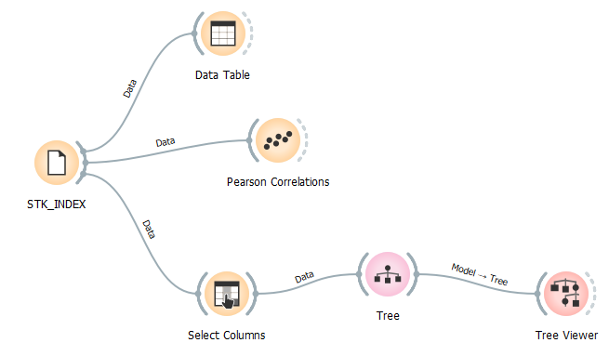

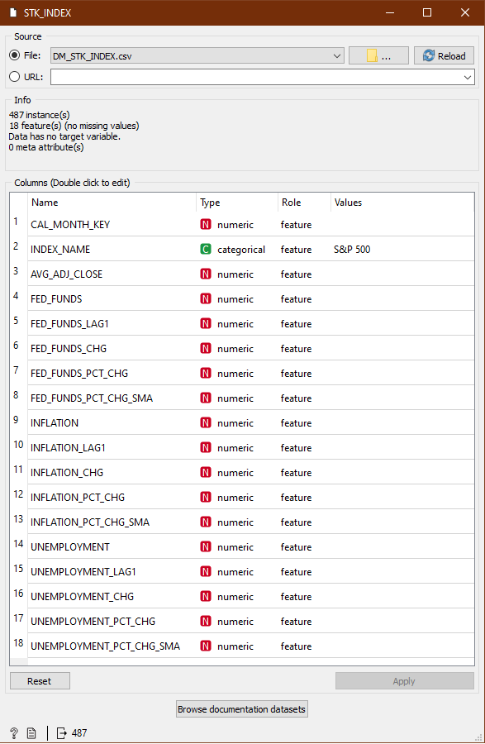

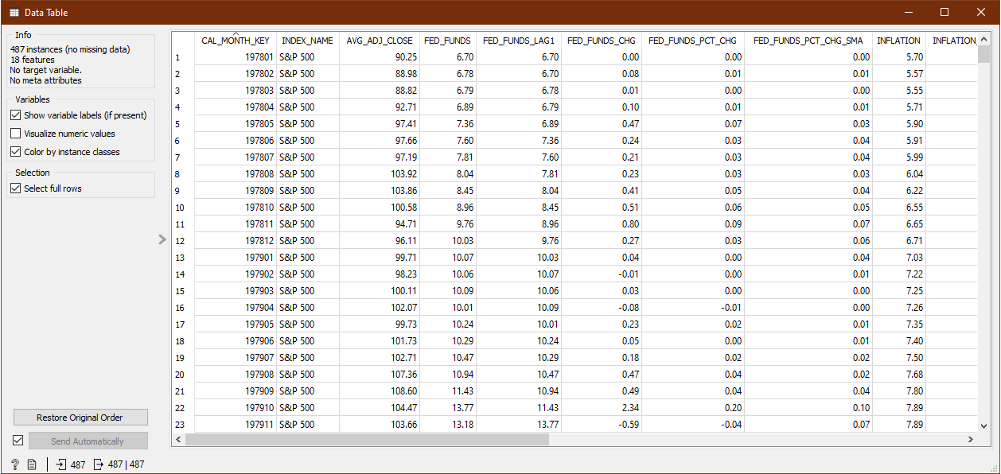

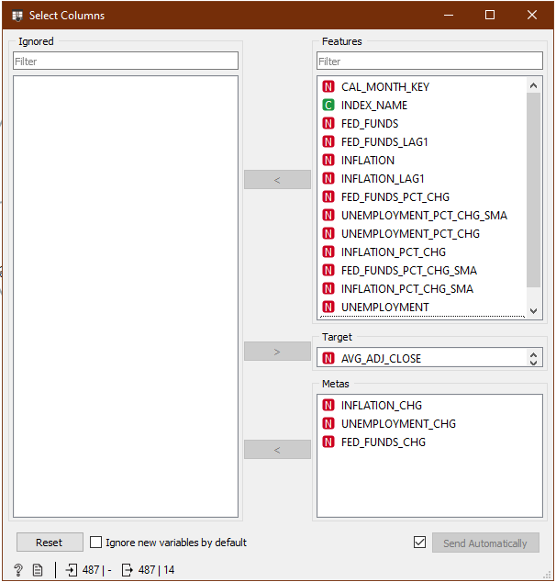

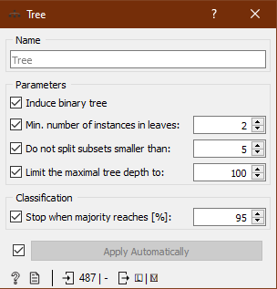

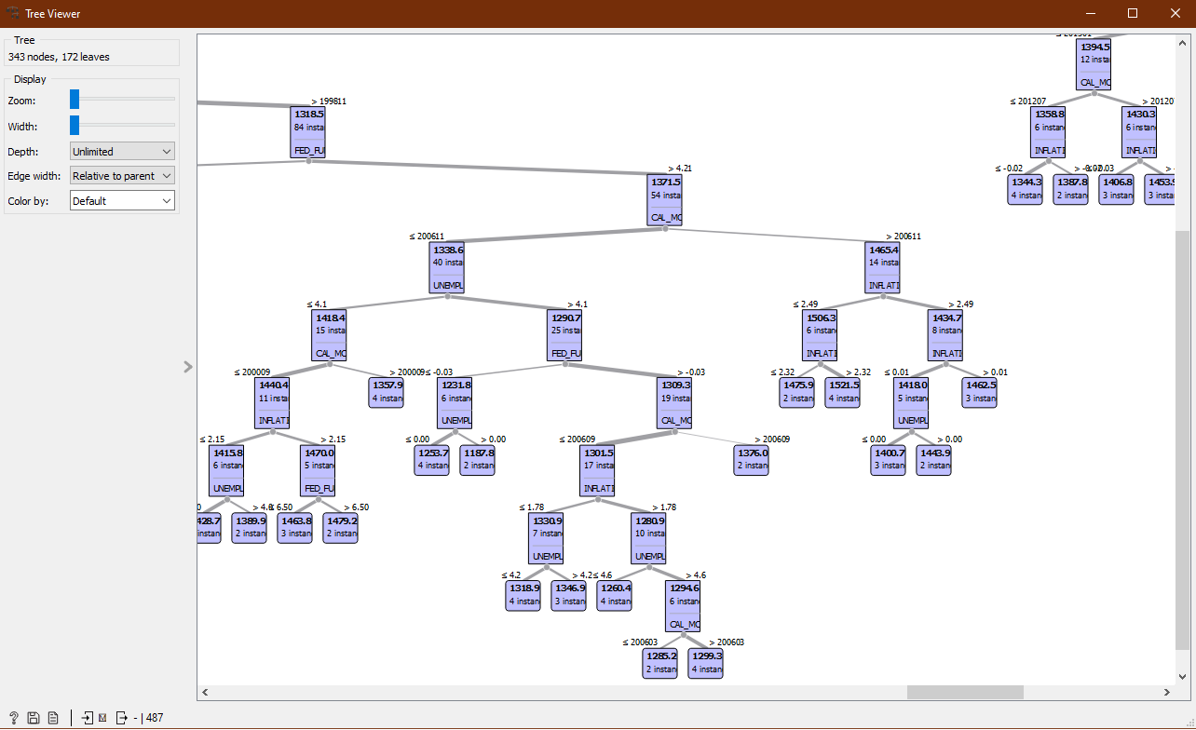

Then I ran some Pearson correlations to see if any useful insights could be gleaned. The FED_FUNDS_LAG1 had the strongest correlation, but it was not strong enough to be considered reliable. Just for kicks, I re-ran the decision tree using FED_FUNDS_LAG1 as the only meta, but the results were essentially the same as the other trees. I also tried ignoring all features except CAL_MONTH_KEY, but the tree results were still essentially the same.

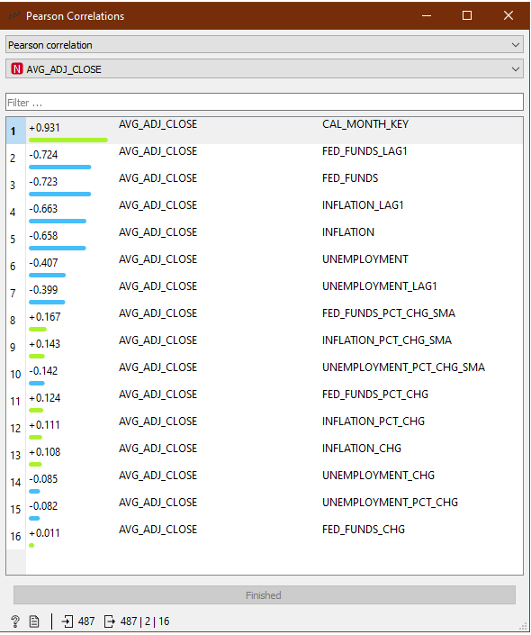

I have not yet taken the Data Mining course, so I am not completely certain how to interpret the decision tree results. However, the large number of leaf nodes seems to suggest none of the chosen economic data are reliable predictors of S&P 500 price movement. The low correlations are certainly evidence of a weak predictive model. These observations strengthen the argument for incorporating other indicators, such as a “Fed Sentiment” indicator, into the model. In my experience, the market usually reacts to Fed comments and other indicators of the Fed’s mindset, which always precede Fed actions.

# Storytelling

For the storytelling requirement, I created a visualization in Tableau using the story telling feature and then [published it to Tableau Public](https://public.tableau.com/app/profile/james.long3817/viz/ISM6208FinalProjectViz/FedFundsStory). Screenshots are included herein should the published workbook not stand the test of time. I would like to have shown the monthly data in more detail to reveal more volatility in the stock indexes. However, with decades of data, the story would have become a saga, and the theme would have been overwhelmed by detail. Despite the smoothing, some coarse correlations (or lack thereof) are visible that reveal an interesting story.

Rather than incorporate all of the candidate predictors, I focused on the Fed Funds rate. Since the data mining effort revealed the strongest correlation to be with the Fed Funds rate, I thought it provided the best opportunity for a useful story to be revealed. In a longer semester, I would have had time to explore the story more fully with multiple predictors.

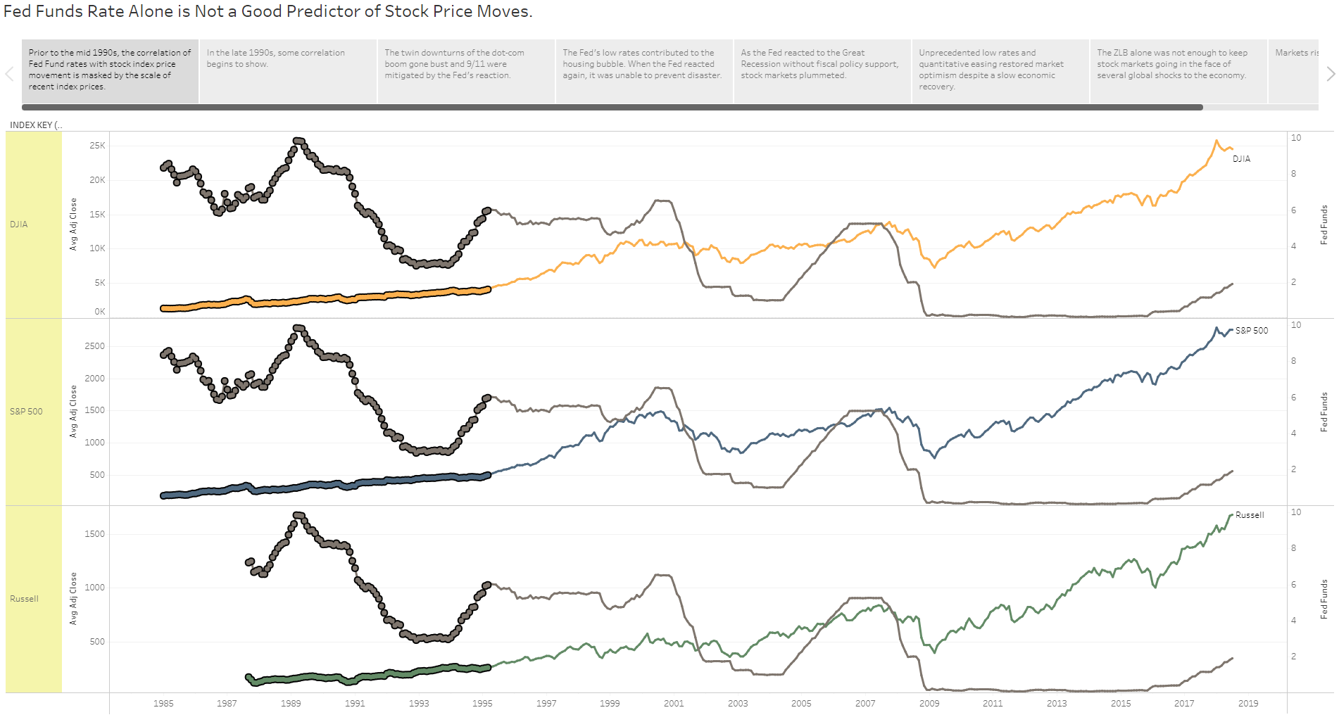

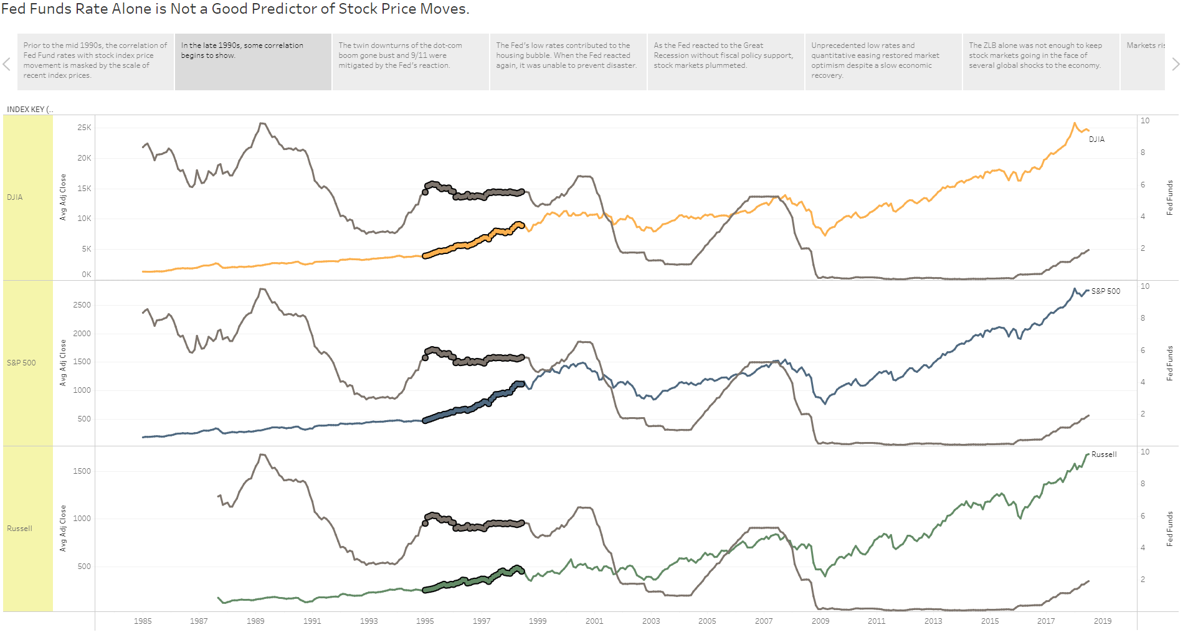

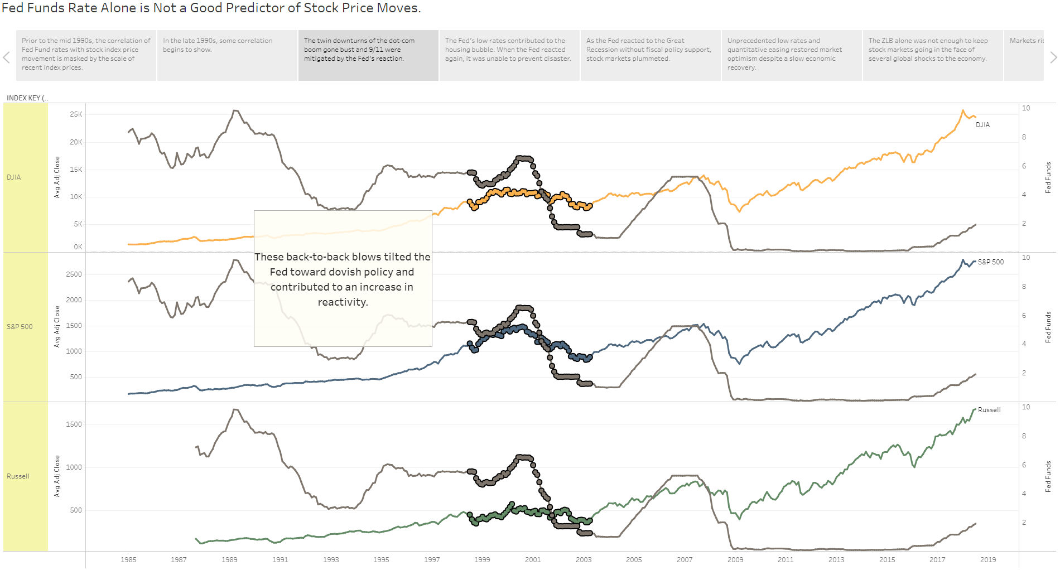

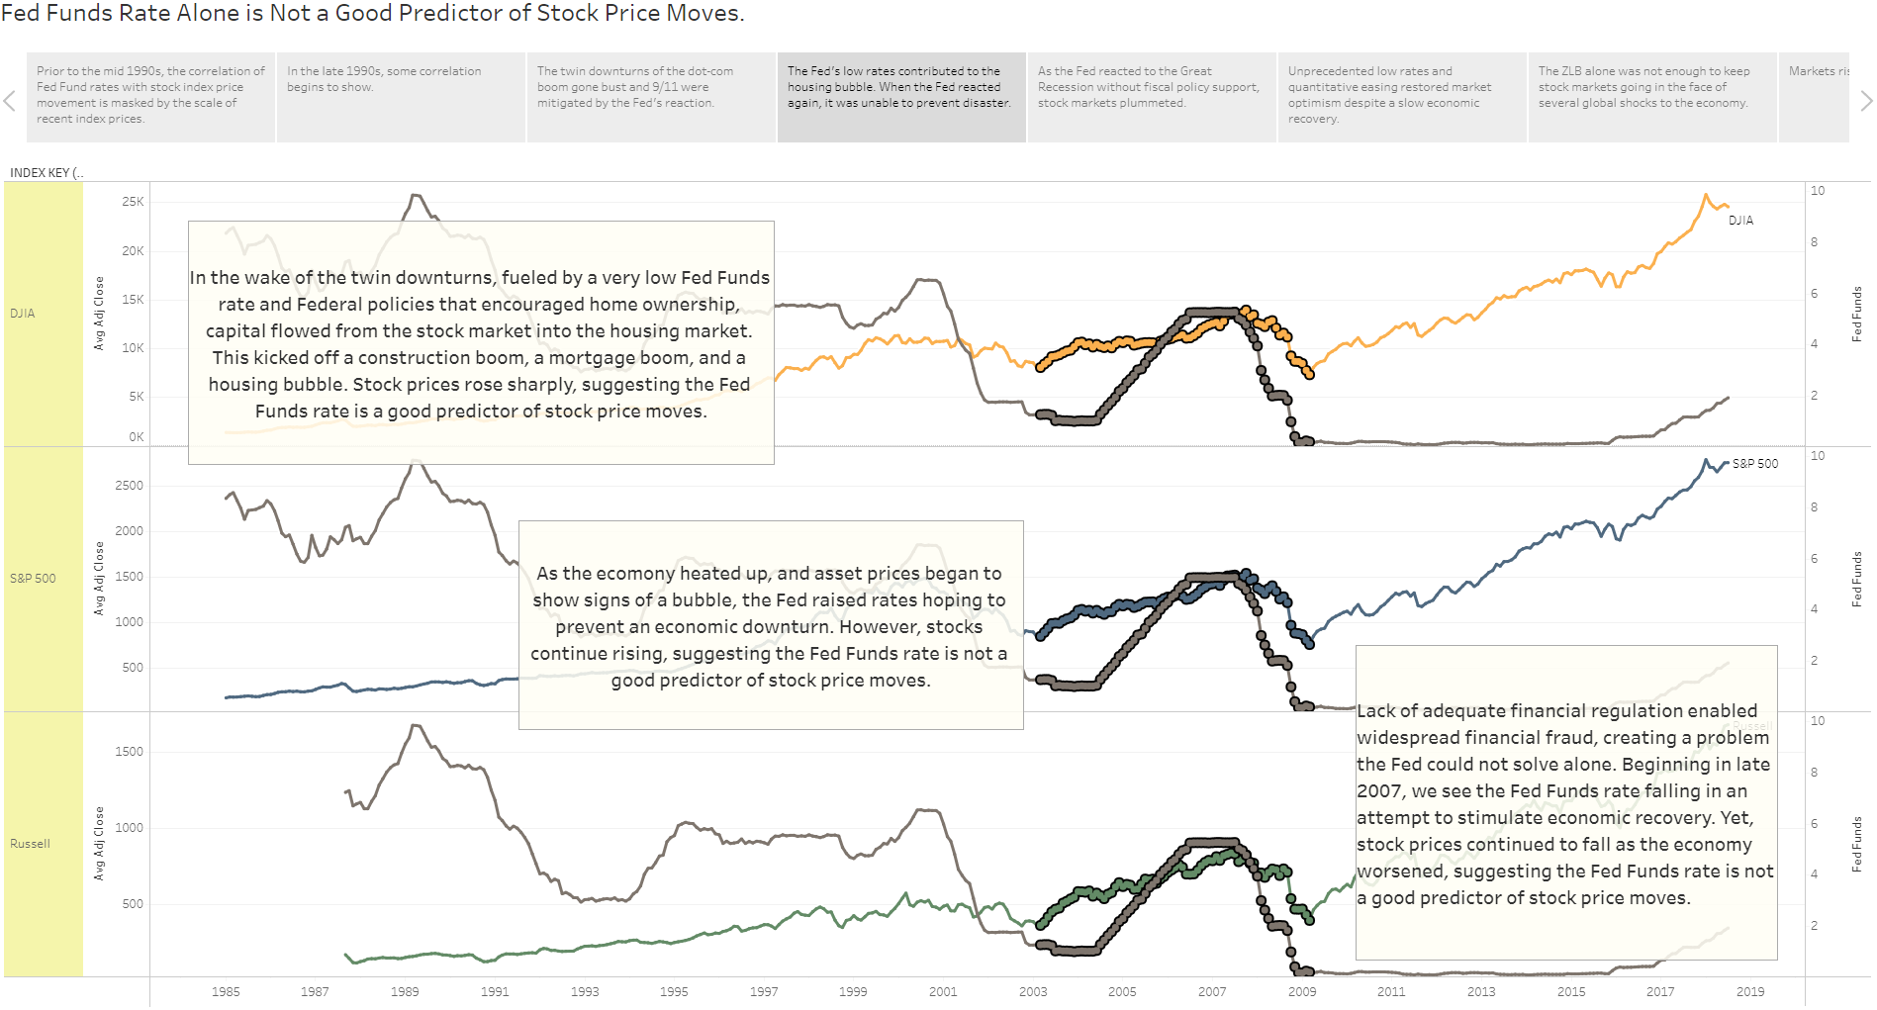

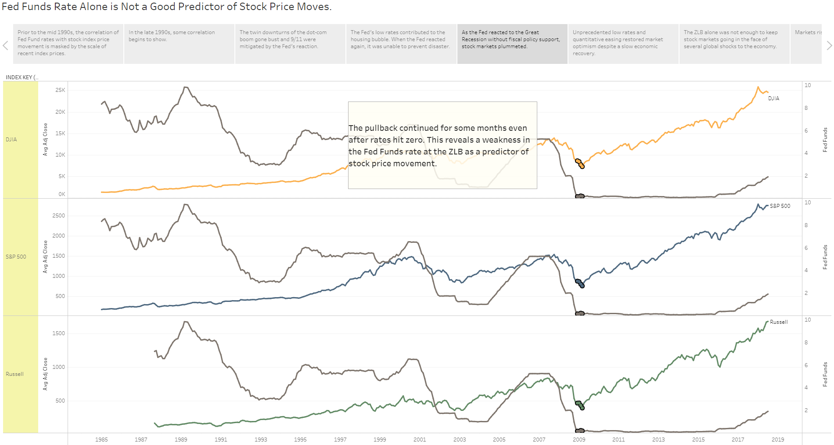

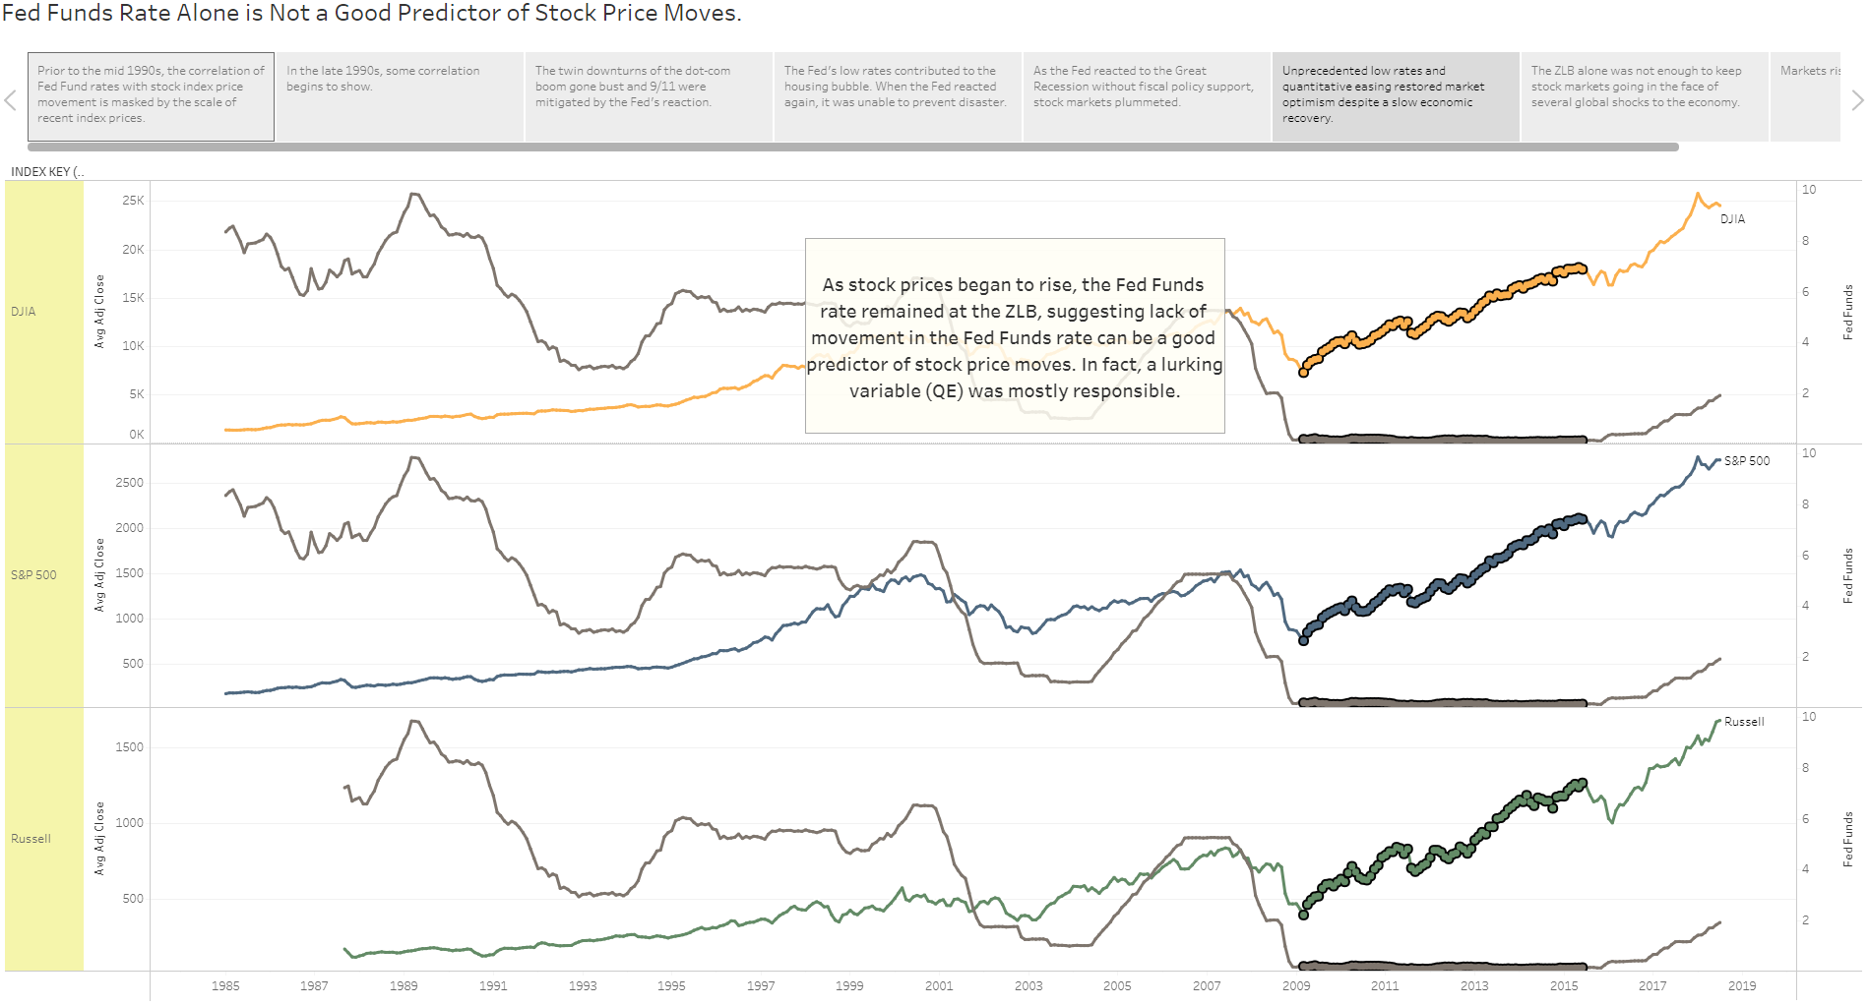

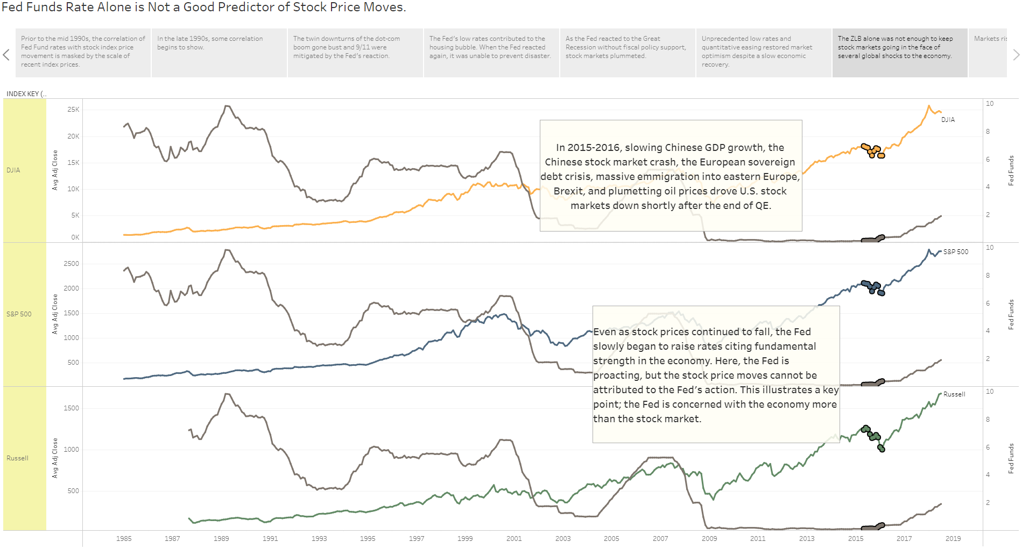

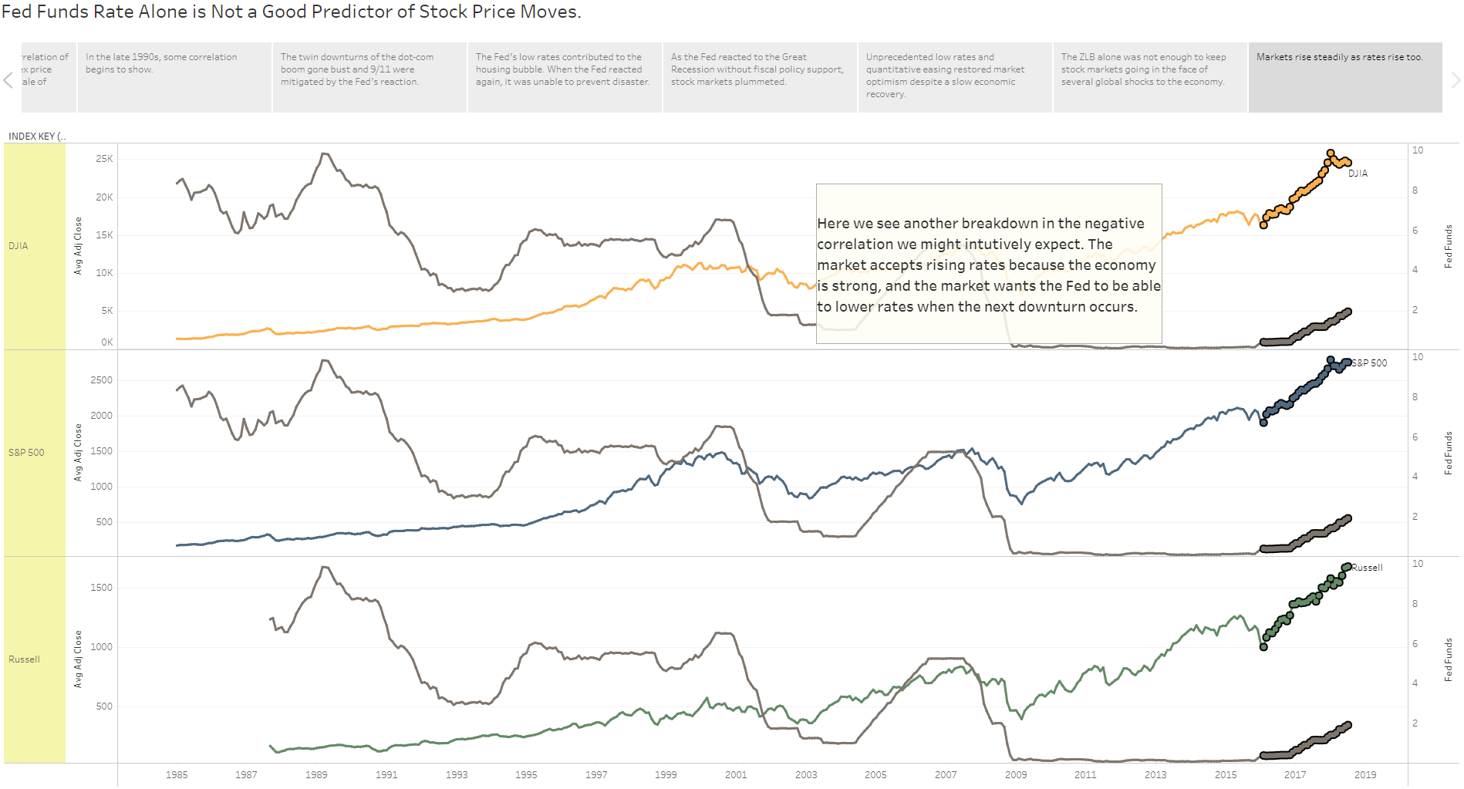

The key take-aways are:

1. The Fed Funds rate alone is not a good predictor of stock index price movement. This visualization corroborates the data mining results.
2. Other Fed tools, like Quantitative Easing (QE), can have even greater influence on stock markets than rate policy.
3. The influence of Fed Funds rate movement can only be properly interpreted by considering other factors such as inflation rates, employment rates, QE activity, world events, financial markets outside the U.S., and so on.

# Conclusions

This project was valuable to me because I learned much about data warehousing. But the value was increased by taking the granular facts all the way through mining and visualization. I can now appreciate the importance of schema design and ETL processes for a quality finished product. And I see how difficult it would be to build a reliable prediction model for anything of even modest complexity.

Perhaps the most valuable lesson is that a model is only as good as its data. Without the right inputs, everything else is a waste of time. In my model, a key data set was missing. The Fed’s communication precedes and has more influence on stock market psychology than Fed actions (such as adjusting the Fed Funds rate). Without this (and perhaps other) key data, my model is a weak predictor of stock index price movement.